**CHAPTER 1**

**INTRODUCTION**

**1.1 ARCHITECTURE**

Database is a collection of related data. DBMS came into existence in 1960 by Charles. Again in 1960 IBM brought IMS-Information management system. In 1970 Edgor Codd at IBM came with new database called RDBMS. In 1980 then came SQL Architecture- Structure Query Language. In 1980 to 1990 there were advances in DBMS e.g. DB2, ORACLE. A database has the following implicit properties:

* A database represents some aspect of the real world, sometimes called the miniworld or the universe of discourse (UoD). Changes to the miniworld are reflected in the database.
* A database is a logically coherent collection of data with some inherent meaning. A random assortment of data cannot correctly be referred to as a database
* A database is designed, built, and populated with data for a specific purpose. It has an intended group of users and some preconceived applications in which these users are interested.

In other word, a database some source from which data is derived, some degree of interaction with events in the real world, and an audience that is actively interested in its contents.

Metadata (meta data, or sometimes meta information) is “data about data”, of any sort in any media. An item of metadata may describe a collection of data including multiple content items and hierarchical levels, for example a database schema. In data processing, metadata is definitional data that provides information about or documentation of other data managed within an application or environment. The term should be used with caution as all data is about something and is therefore metadata.

A database management system (DBMS) is a collection of programs that enables users to create and maintain database. The DBMS is a general-purpose software system that facilitates the process of defining, constructing, manipulating and sharing databases among various users and applications.

Defining a database specifying the database involves specifying the data types, constraints and structures of the data to be stored in the database. The descriptive information is also stored in the database in the form database catalogue or dictionary; it is called meta-data. Manipulating the data includes the querying the database to retrieve the specific data. An application program accesses the database by sending the queries or requests for data to DBMS. The important function provided by the DBMS includes protecting the database and maintain the database.

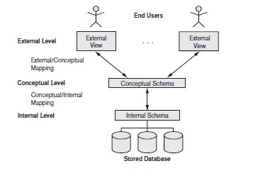

**Figure 1.1: Three Schema Architecture**

The Figure 1.1 shows the Three schema architecture of Database Management System. The Three schema architecture consists of three levels of the architecture:

* **External Level:**

The external level is the view that the individual user of the database has. This view is often a restricted view of the database and the same database may provide a number of different views for different classes of users. In general, the end users and even the application programmers are only interested in a subset of the database.

* **Conceptual Level:**

The conceptual view is the information model of the enterprise and contains the view of the whole enterprise without any concern for the physical implementation. The conceptual view is the overall community view of the database and it includes all the information that is going to be represented in the database.

* **Internal Level:**

the internal view is the view about the actual physical storage of data. It describes what data is stored in database and how.

**1.2 OVERVIEW OF THE PROJECT**

**1.2.1 PROBLEM STATEMENT**

To maintain and manipulate the data of the football players using Football Management System.

**1.2.2 OVERVIEW**

The Football Database Management System creates software that stores and manages all the data related to statistics of a football player. It also includes a fun section for users who are not registered and are not having administrational authority.

It has a database administration that has access to the entire database, in regards with viewing and update of information. Also viewing all data and editing of player’s data can be done by any successfully registered user. The data of players is well protected for use and data processing. It can be used by any person or professional who are interested in knowing details about football players. Facilities available in this mini project are maintaining record of different players, viewing the top ten players around the world at this moment, transferring the players from one club to another based on some conditions, booking a ticket for coming match, viewing stats of your favorite player. The goals are planned approach towards working, accuracy, reliability, no redundancy and immediate retrieval of information.

**1.2.3 OBJECTIVES OF THE PROPOSED SYSTEM**

The main objective of this system are:

* Search for all players, teams and their statistics.
* Booking tickets for upcoming matches.
* Transferring of a player from one club to another.
* Keeping track of top ten players of the world anytime user wants to see.
* Ensure data accuracy, efficiency and security.

**CHAPTER 2**

**SYSTEM DESIGN AND METHODOLOGY**

**2.1 SYSTEM ARCHITECTURE**

The main software used for this are Html5, PHP and WampServer.

**PHP: Hypertext Preprocessor** is server language designed for web development and used as a general-purpose programming language. PHP code may be embedded into HTML code, or it can be used in combination with various web templates system, web content management systems, and web frameworks. PHP code is usually processed by a PHP interpreter implemented as a module in the web server or as a common gateway interface executable. The web server combines the results of the interpreted and executed PHP code, which may be any type of data, including images, with the generated web page. The PHP interpreter only executes PHP code within its delimiters. Anything outside its delimiters is not processed by PHP, although non-PHP text is still subject to control structures described in PHP code. The most common delimiters are *<?php* to open and?*>* to close PHP sections. The shortened form *<?* also exists.

**HTML: Hypertext Markup Language**is a markup language for creating a webpage. Webpages are usually viewed in a web browser. They can include writing, links, pictures, and even sound and video. HTML is used to mark and describe each of these kinds of content, so the web browser can display them correctly. HTML can also be used to add meta information to a webpage. Meta information is usually not shown by web browsers and is data about the web page, e.g., the name of the person who created the page. Cascading style sheets CSS is used to style HTML elements while JavaScript is used to manipulate HTML elements and CSS styles.

**2.2 ENTITY RELATIONSHIP DIAGRAM**

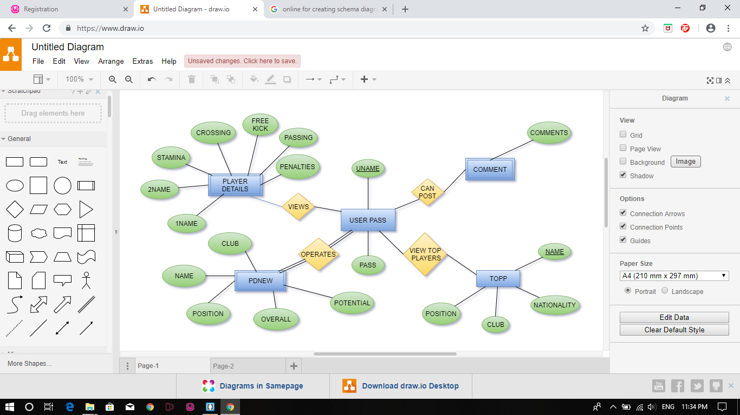

Figure 2.1: ER Diagram

An Entity-Relationship Diagram (ERD) is a data modelling technique that graphically illustrates an information system’s entities and the relationships between those entities. An ERD is a conceptual and representation model of data used to represent the entity framework infrastructure. The above figure 2.1 illustrates the following:

* The players detail entity has the following attributes 1name, 2name, stamina, freekick, passing, crossing, penalties.
* The user pass entity has the following attributes uname and pass where uname is a primary key.
* The pdnew entity has the following attributes name, club, potential, overall, position.
* The comment entity is having only one attribute named comments.
* The top entity is having following attributes name, nationality, position, club.

**2.3 SCHEMA DIAGRAM**

**USERPASS**

|  |  |
| --- | --- |
| **UNAME** | **PASS** |

**PLAYER DETAILS**

|  |  |  |  |  |  |  |
| --- | --- | --- | --- | --- | --- | --- |
| **1NAME** | **2NAME** | **STAMINA** | **CROSSING** | **FREEKICK** | **PASSING** | **PENALTIE** |

**PDNEW**

|  |  |  |  |  |
| --- | --- | --- | --- | --- |
| **NAME** | **CLUB** | **POSITION** | **OVERALL** | **POTENTIAL** |

**TOPP**

|  |  |  |  |
| --- | --- | --- | --- |
| **NAME** | **NATIONALITY** | **CLUB** | **POSITION** |

**COMMENT**

|  |
| --- |
| **COMMENTS** |

Figure 2.2 Schema Diagram

**2.4 PROJECT REQUIREMENTS**

|  |  |  |  |
| --- | --- | --- | --- |
| ***Hardware Requirements*** | | | |
| ***Processor*** | ***RAM*** | | ***Disk Space*** |
| Pentium i3, i5 or more | 4 GB of Higher | | 10 GB or more |
| *Software Requirements* | | | |
| ***Operating System*** | | ***Language/Tools/Database*** | |
| Windows 7, 8, 10 | | HTML5, PHP/ WAMP Server and Brackets/MySQL | |

Figure 2.3 Project Requirement

**2.5 ALGORITHMS**

**TRIGGER:**

To validate the username and password before a user is able to perform any changes to database.

**STEP 1:** BEGIN

**STEP 2:** Before register a user needs to register using username and password

**STEP 3:** After the input from user, execute query “SELECT * FROM userpass WHERE uid='$uname' &&

Pass=’$pass’;”

**STEP 4:** if the number of rows returned by the query is one login is successful and user is redirected to

login page.

END if

else login failed

**STEP 5:** END

**Explanation:** After taking user id and password from the user, the system will verify if that user id and pass exist in table using query in step3 and if exits it will redirect user to login page, otherwise an error message will be displayed.

**STORED PROCEDURE:**

To view list of all players and their statistics.

**STEP 1:** BEGIN

**STEP 2:** Create procedure getPdnew

**STEP 3:** select * from pdnew;

**STEP 4:**  Call this multiple whenever list of players are required

**STEP 5:** END

**Explanation:** Here we are creating a procedure named getPdnew through which whenever we want to view players list, we can directly call this procedure.

**CHAPTER 3**

**SYSTEM IMPLEMENTATION**

To implement this mini project, WAMP server is used for backend, html is used for front end and php is used for server-side scripting.

Some features of PHP are:

* **Simple:** It is very simple and easy to use, compare to other scripting language it is very simple and easy, this is widely used all over the world.
* **Faster:** It is faster than other scripting language e.g. asp and jsp.
* **Open Source:** Open source means you no need to pay for use php, you can free download and use.
* **Interpreted:** It is an interpreted language, i.e. there is no need for compilation.
* **Platform Independent:** PHP code will be run on every platform, Linux, Unix, Mac OS X, Windows.
* **Case Sensitive:** PHP is case sensitive scripting language at time of variable declaration. In PHP, all keywords (e.g. if, else, while, echo, etc.), classes, functions, and user-defined functions are NOT case-sensitive.
* **Error Reporting:** PHP have some predefined error reporting constants to generate a warning or error notice.
* **Real-Time Access Monitoring:** PHP provides access logging by creating the summary of recent accesses for the user.
* **Loosely Typed Language:** PHP supports variable usage without declaring its data type. It will be taken at the time of the execution based on the type of data it has on its value.

Some features of HTML5 are:

* **Web Workers:** Certain web applications use heavy scripts to perform functions. Web Workers use separate background threads for processing and it does not affect the performance of a web page.
* **Video:** You can embed video without third-party proprietary plug-ins or codec. Video becomes as easy as embedding an image.
* **Canvas:** This feature allows a web developer to render graphics on the fly. As with video, there is no need for a plug in.
* **Application caches:** Web pages will start storing more and more information locally on the visitor's computer. It works like cookies, but where cookies are small, the new feature allows for much larger files. Google Gears is an excellent example of this in action.
* **Geolocation:** Best known for use on mobile devices, geolocation is coming with HTML5.

**3.1 MODULE DESCRIPTION**

The modules included in this mini project are:

**HOME PAGE**

**OBJECTIVE:**

This is the front page which provides different authentication option and contains basic details about this system.

**INPUT:**

The user can select Sign IN, Sign UP or Top ten player list.

**OUTPUT:**

* + On selecting Sign IN the user is redirected to a login page, where only registered user can successfully login.
  + On selecting Sign UP the user is redirected to a register page, where any new user can register before signing in.
  + On selecting Top ten player list, user is provided with the list of top ten players of the world.

**DESCRIPTION:**

Front end is designed using HTML5 and CSS3. The user will be taken to the login page from where an user can have the permission to perform various operations on database.

**CODE SNIPPET:**

**<div class="mbr-section-btn form-container">**

**<a class="btn btn-md btn-dark display-4" href="login.php">Sign IN</a>**

**<a class="btn btn-md btn-warning display-4" href="register.php">Sign UP</a>**

**<a class="btn btn-md btn-dark display-4" href="form.html">Top ten Players</a>**

**</div>**

**REGISTER PAGE**

**OBJECTIVE:**

This is the register page where a new user with unique user id and password can register themselves for further login process.

**INPUT:**

Username and password

**OUTPUT:**

A successful registration shall take the user to login page. On entering invalid username or password an error message will be displayed.

**DESCRIPTION:**

Front end is designed using HTML5 and CSS3. On registering successfully, the user can now use the same id and password to login any time and to access all the operations available for user to perform.

**CODE SNIPPET:**

**if(isset($_POST['submit']))**

**{**

**$uname = $_POST['userid'];**

**$pass = $_POST['password'];**

**$query1 = "insert into userpass values('$uname','$pass') ";**

**$data1 = mysqli_query($con,$query1);**

**if($data1)**

**{ header('location:login.php')}**

**}**

**else**

**{ echo "<h3><font color='white'>All Fields are required</font></h3>"; }**

**LOGIN PAGE**

**OBJECTIVE:**

This is the login page where an already registered user with their user id and password can login themselves to the football management system for further database operations.

**INPUT:**

Username and password

**OUTPUT:**

A successful login shall take the user to Database operation page. On entering invalid username or password an error message will be displayed.

**DESCRIPTION:**

Front end is designed using HTML5 and CSS3. On logging in successfully the user can access all the operations available for user to perform on the database.

**CODE SNIPPET:**

**if(isset($_POST['submit']))**

**{**

**$uname = $_POST['userid'];**

**$pass = $_POST['password'];**

**$query = "SELECT * FROM userpass WHERE uid='$uname' && pass='$pass'";**

**$data = mysqli_query($con,$query);**

**$row = mysqli_num_rows($data);**

**if($row == 1)**

**{ header('location:index1.html'); }**

**else**

**{**

**echo "<h2><font color='white'> Login Failed !!!</h2>";**

**}**

**}**

**MANAGER PAGE**

**OBJECTIVE:**

This is the manager page where a registered user can act as a manager and can perform operation like inserting a player, deleting a player and transferring a player based on search operation.

**INPUT:**

Player name, position and their club.

**OUTPUT:**

A successful insertion, deletion and transfer operation on players.

**DESCRIPTION:**

Front end is designed using HTML5 and CSS3. On transferring successfully the user will get a successful transfer message.

**CODE SNIPPET:**

**if($name!="" && $pos!="" && $club!="" )**

**{**

**$q=" UPDATE `pdnew` SET Name ='$Name',`Position`='$pos',`Club`='$club' WHERE Name ='$name' ";**

**$query = mysqli_query($con,$q);**

**if($query)**

**echo "<font color='white'>Transfer Done Successfully. <a href='trans.php'>Check Transfered List Here</a></font>";**

**}**

**else**

**{**

**echo "<font color='white'>All fields are required</font>";**

**}**

**CHAPTER 4**

**RESULT AND SCREENSHOTS**

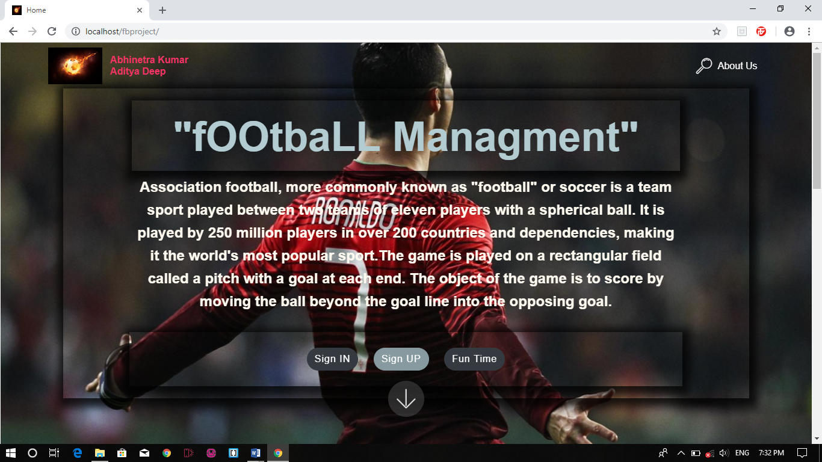Figure.4.1 Index Page

Figure.4.1 shows ‘Index Page’ where the users can see all the details of the mini project

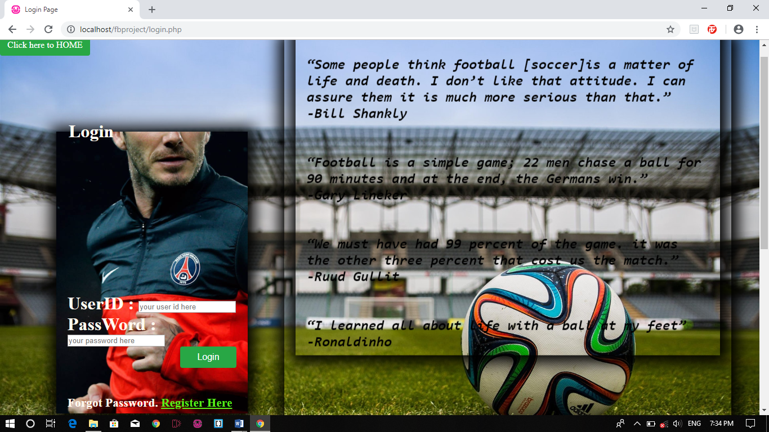Figure.4.2 Sign IN page

Figure.4.2 shows ‘Login Page’ and this page is displayed when user want to Login.

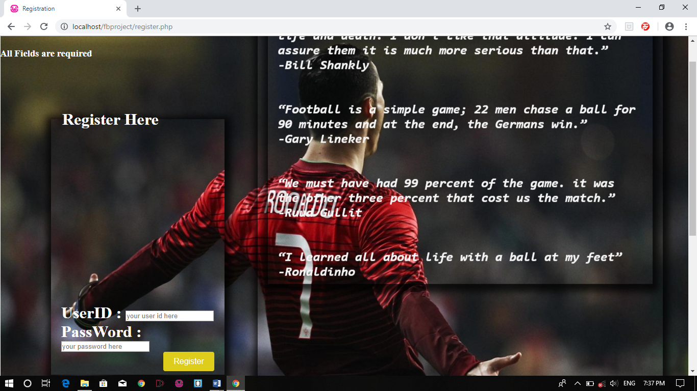Figure 4.3 Sign Up Page

Figure 4.3 shows ‘Signup Page’ which is for users to register.

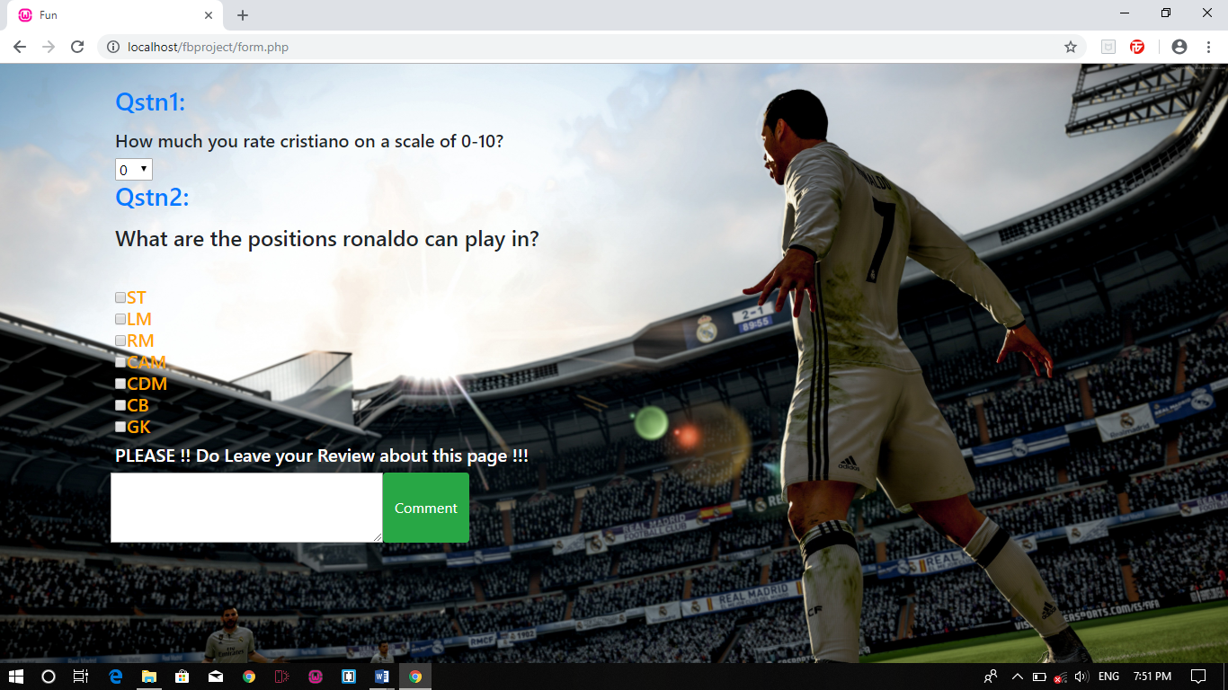

Figure 4.4 Fun Page

Figure 4.4 shows ‘Fun Page’ which is for users to give feedback on behalf of this mini project.

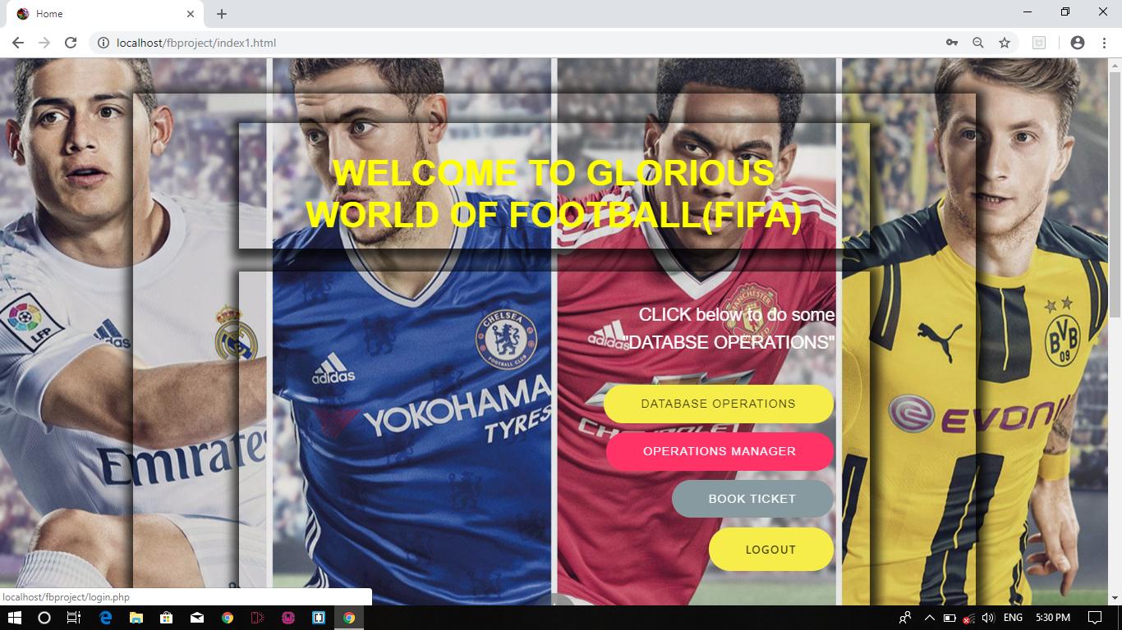Figure 4.5 Home Page.

Figure 4.5 shows ‘Home Page’ which appears when user successfully login.

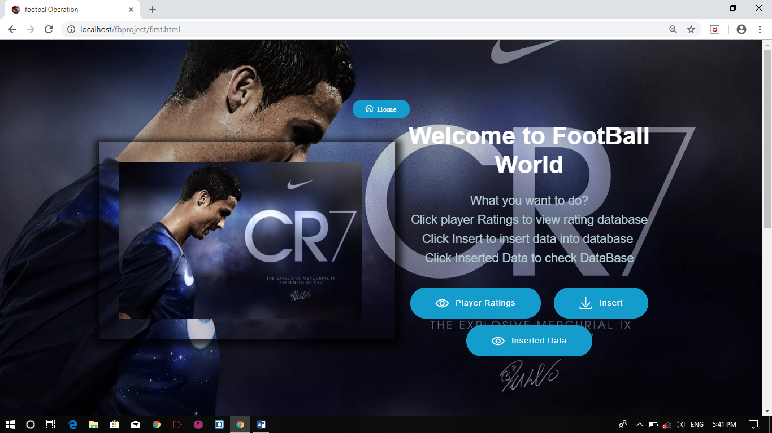Figure 4.6 Database operation page.

Figure 4.6 shows ‘Database Operations’ which is for doing some database operations like view, insert, delete and update.

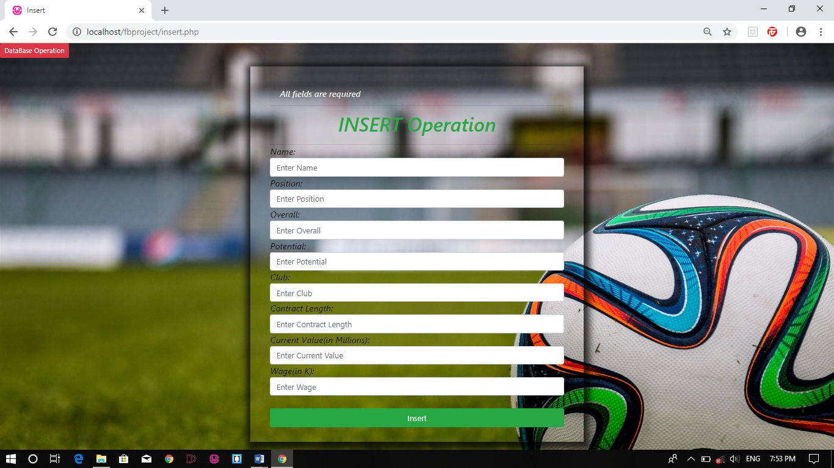Figure 4.7 Insert Operation

Figure 4.7 shows ‘Insert Page’ which is for inserting details of some player.

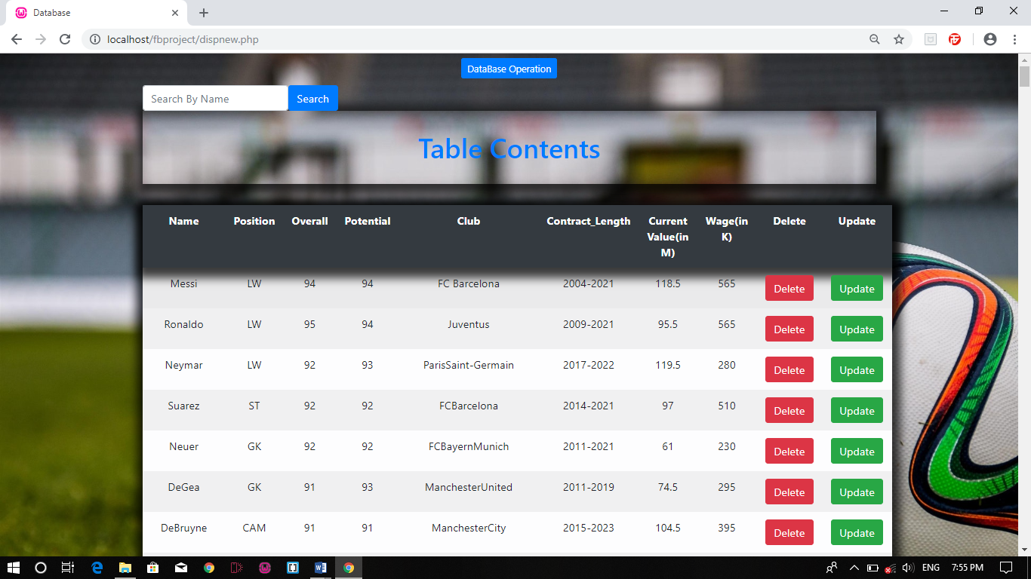Figure 4.8 Table with Update, Delete and Search Operations

Figure 4.8 shows ‘Table Contents’ which is for viewing details of all players along with delete, update and search operations.

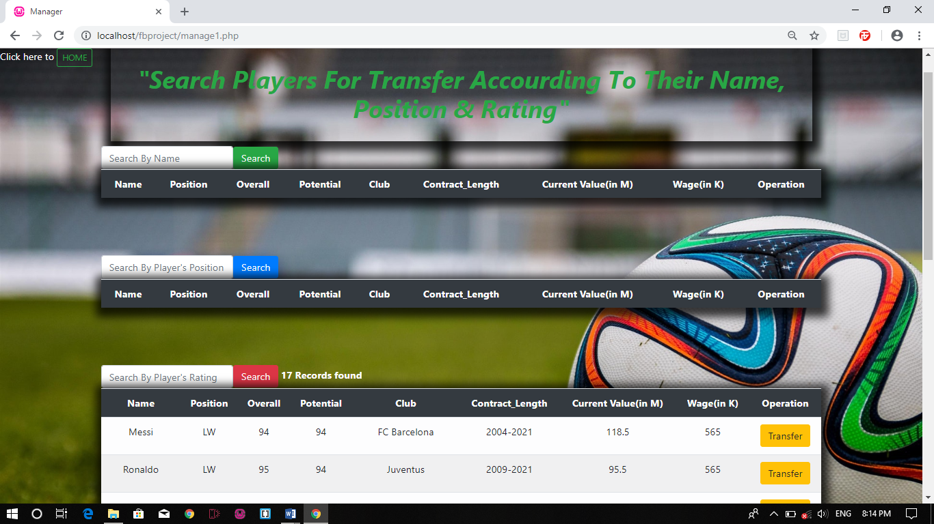Figure 4.9 Manager Page

Figure 4.9 shows ‘Manager Page’ which is for Managers to transfer players after searching them on basis of Players’ name, position and overall ratings.

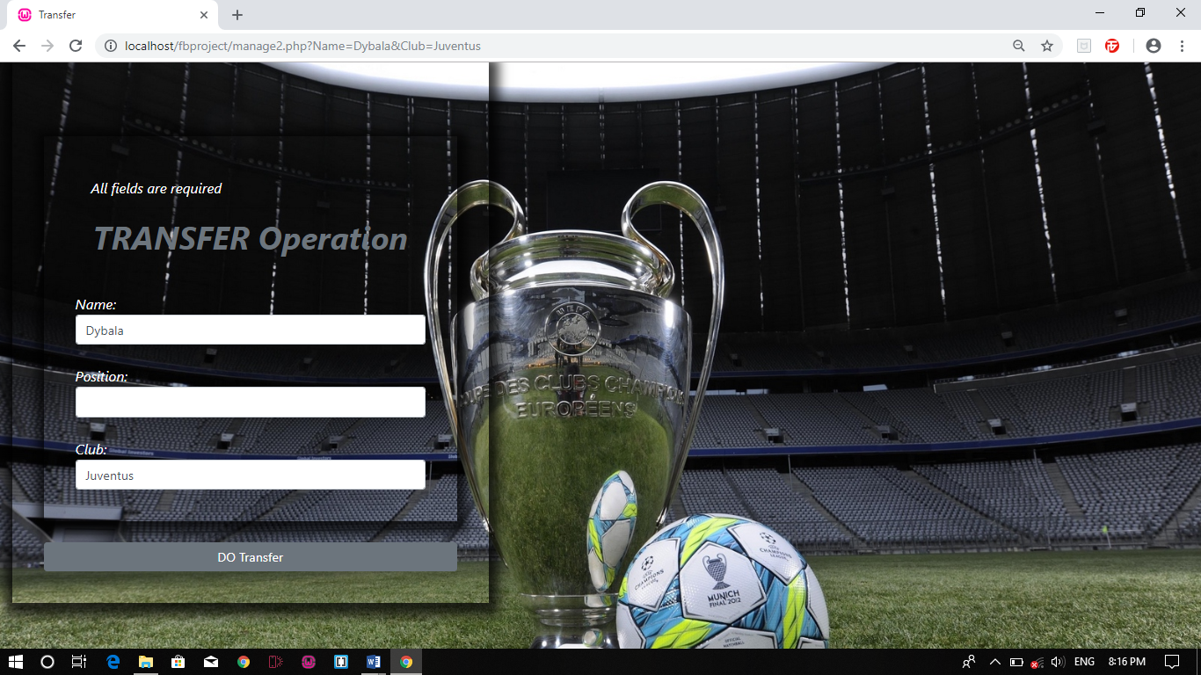Figure 4.10 Transfer Page

Figure 4.10 shows ‘Transfer Page’ which is for manager to transfer a player from one club to another club after giving 10% extra wage to player.

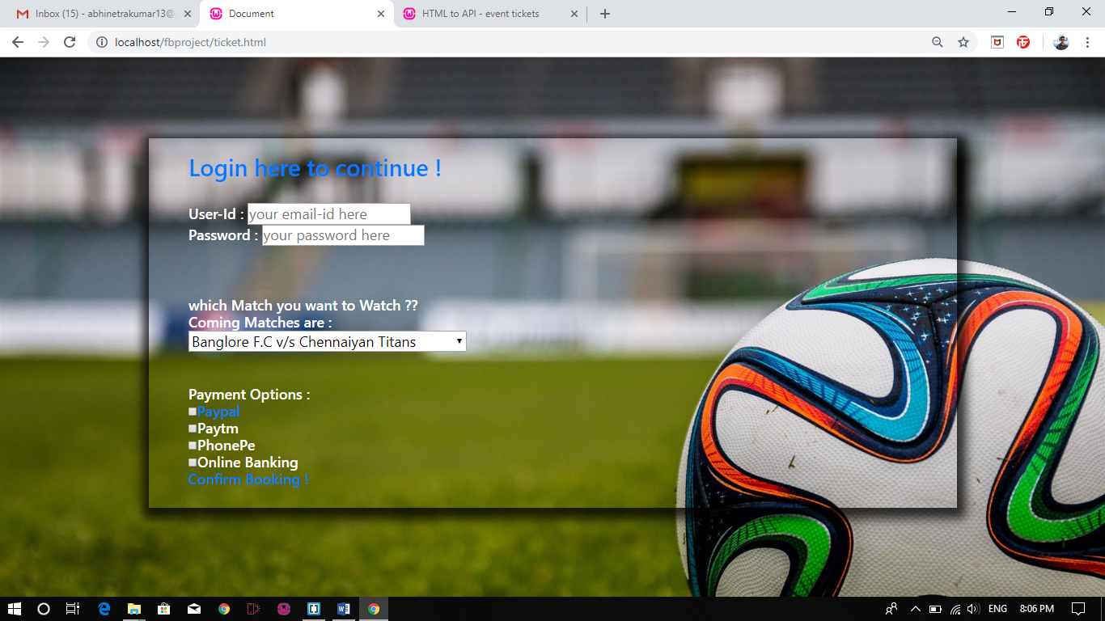

Figure 4.11 Ticket Booking Page

Figure 4.11 shows ‘Ticket Booking Page’ which is use for users to book ticket for upcoming matches.

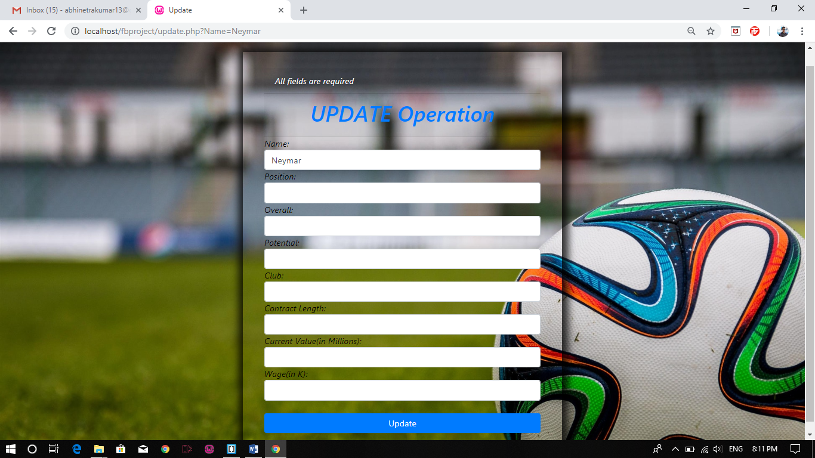

Figure 4. 12 Update page.

Figure 4.12 shows ‘Update Operation’ which is used to update the player’s details if necessary.

**CONCLUSION**

This mini project has been developed using WAMP server and php programming to meet the requirements of football fans such as players statistics, ticket booking and lot more. The data can be accessed, manipulated and retrieved very easily. To conclude, this software has proved to be a user friendly.

**FUTURE WORKS**

1. The mini project shall host the platform on online servers to make it accessible worldwide.
2. The mini project shall integrate multiple load balancers to distribute loads on system.
3. Introduction of machine learning in this mini project to predict the coming performance of a player or to predict the next transfer of a player.

**BIBLIOGRAPHY**

1. [www.youtube.com](http://www.youtube.com)
2. [www.w3school.com](http://www.w3school.com)
3. [www.tutorialpoint.com](http://www.tutorialpoint.com)
4. [www.stackoverflow.com](http://www.stackoverflow.com)